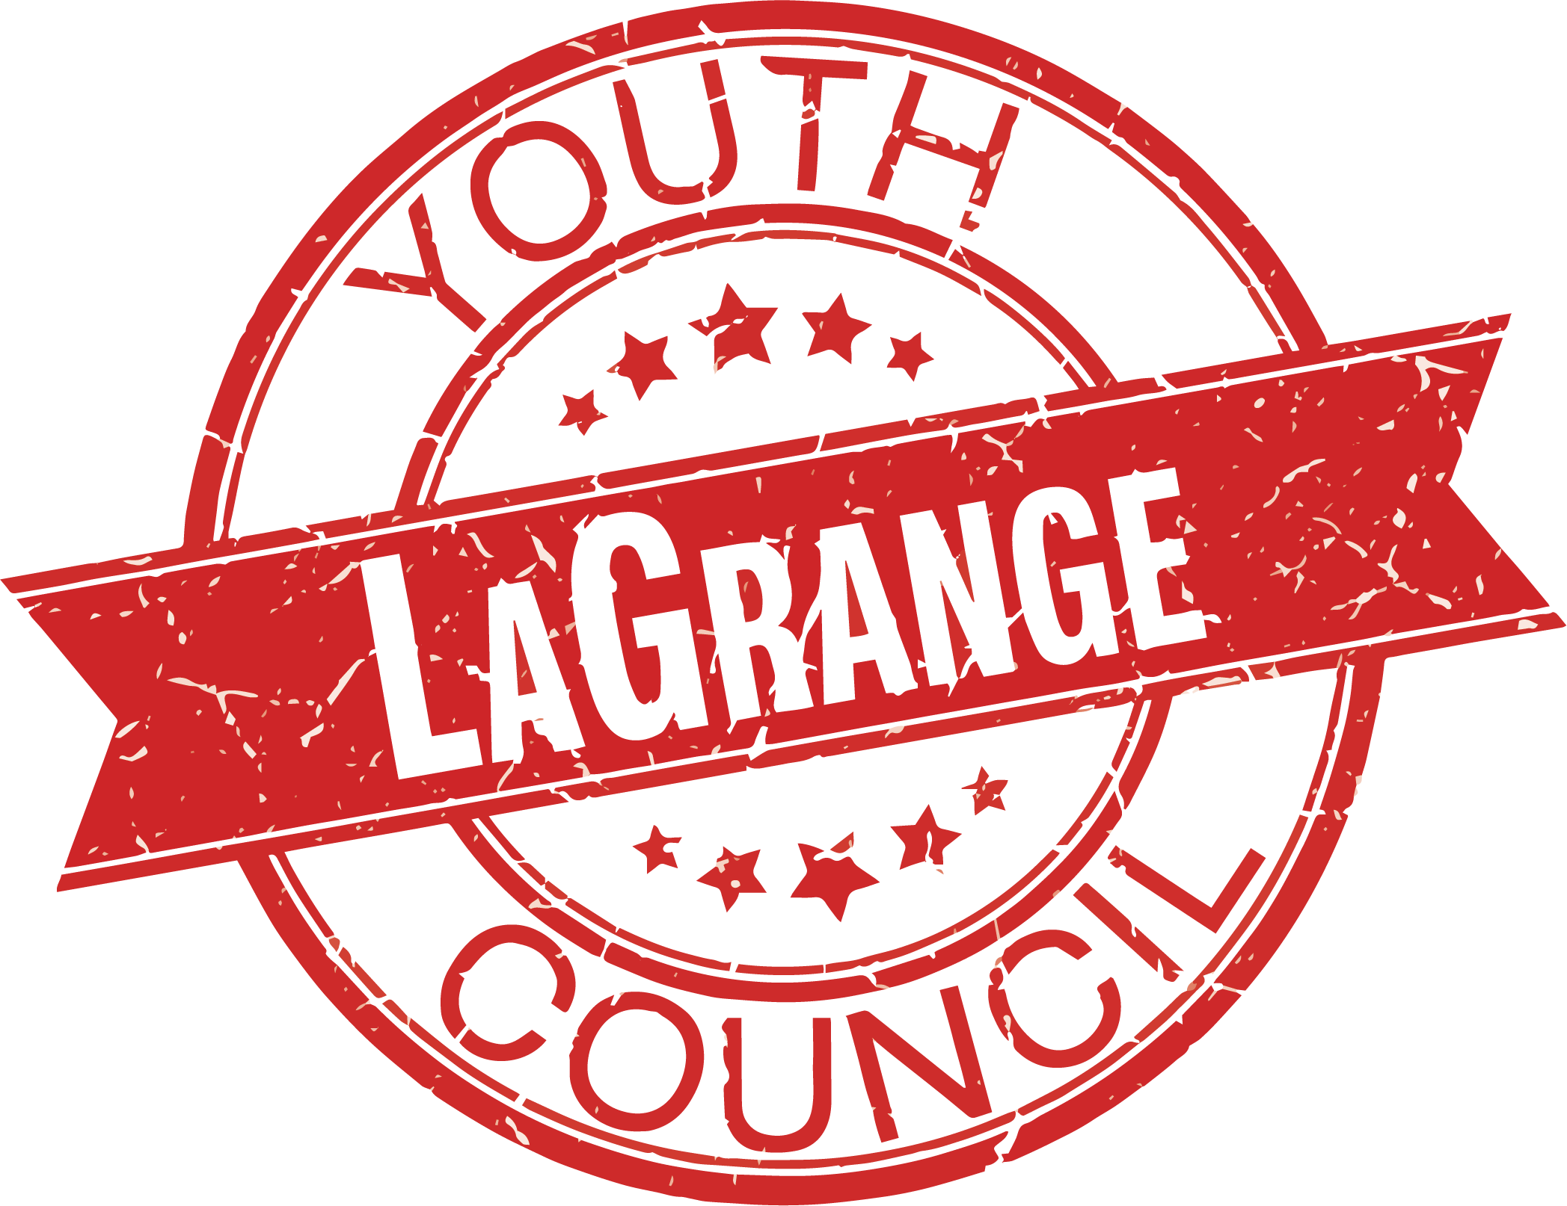

CITY OF LAGRANGE, GEORGIA
LAGRANGE YOUTH COUNCIL STUDENT APPLICATION
(2020-2021)

Deadline for submission: Friday, August 28, 2020

In order to be considered, student applicants must meet the following criteria:
- Submittal of this application filled out in its entirety no later than Friday, August 28, 2020. Interviews will be held August 31- September 11. LaGrange Council Members will be selected by September 14th.
- Be presently enrolled in high school. Applicant will be a junior or a senior in 2020-2021.
- Attend the mandatory summer orientation training session in September 2020.
- Be academically eligible to participate in school sports and extra curricular activities.
- Be free of any serious disciplinary infractions within the last six months.
- Be able to think critically and articulate thoughts and ideas.
- Have an interest in learning about government and how it functions.
- Possess potential leadership skills.
- Secure parental or guardian permission and support.
- Must be a resident of the City of LaGrange

Applicant’s Name: __________________________________________________________________________

Street Address:______________________________________________________________________________

City, State, & Zip Code: ______________________________________________________________________

Home Phone Number:_____________________________ Other Number: ______________________________

Email Address:_____________________________________________________________________________

Age: ______________ Date of Birth: ________/________/____________

School (Present):___________________________________________ Grade (present):___________________

School (Next school year if different) ___________________________________________________________

The adults, listed below as references, should be able to answer questions concerning the applicant’s qualifications for a membership position on the LaGrange Youth Council. One adult reference must be from a teacher, counselor, or school administrator. The second adult reference must be from a civic or community leader. Please list references below. References will be contacted by the Youth Advisory Board.

1. Name ___________________________________________ Relation to applicant: _____________________

Email Address: _______________________________________

2. Name ___________________________________________ Relation to applicant: _____________________

Email Address: _________________________________________
Please list any extracurricular activities you have been involved in.
___________________________________________________________________________________________________________________________________________________
__________________________________________________________________________________________________

Please list any involvement in community service or special projects.
_____________________________________________________________________________________________________________________________________________________________________________________________________________________________________________________

What motivates you to want to become a member of the LaGrange Youth Council?
_____________________________________________________________________________________________________________________________________________________________________________________________________________________________________________________

What programs, activities or issues would you like to see addressed by the LaGrange Youth Council?
_____________________________________________________________________________________________________________________________________________________________________________________________________________________________________________________

How would you contribute to the LaGrange Youth Council?
________________________________________________________________________________________________________________________________________________________________________________________________

Based on the commitments you have already made for the upcoming school year, could you dedicate approximately 4-8 hours or more per month to the LaGrange Youth Council?
Yes ________ No _________

Do you foresee any conflicts with the schedule? If so, what?
____________________________________________________________________________________________________________________________________________________________________________________________________
_________________________________________________

I, __________________________, verify that the information that I have included on the application is correct to the best of my knowledge. I am interested in serving my community on the City of LaGrange Youth Council and if selected, I will abide by all of the rules and regulations set forth by the Youth Advisory Board and the LaGrange City Council.

Student Signature: __________________________________________________ Date:___________________

I, __________________________________, the parent or legal guardian of ____________________________,
grant permission to my son/daughter to serve on the City of LaGrange Youth Council and grant permission for him/her to participate in all activities of the Youth Council and, if selected, will assist him/her in this endeavor and further grant permission for the release of my child’s grades to the LaGrange Youth Advisory Board for review and evaluation.

Parent Signature: __________________________________________________ Date: ____________________

After completing the application form, please mail the completed form directly to:

City of LaGrange
LaGrange Youth Council
200 Ridley Avenue
LaGrange, GA 30240
Attention: Katie Van Schoor, City of LaGrange Marketing/Communications Manager

