Oath of Office
Eatonton Youth Council
Eatonton, Georgia
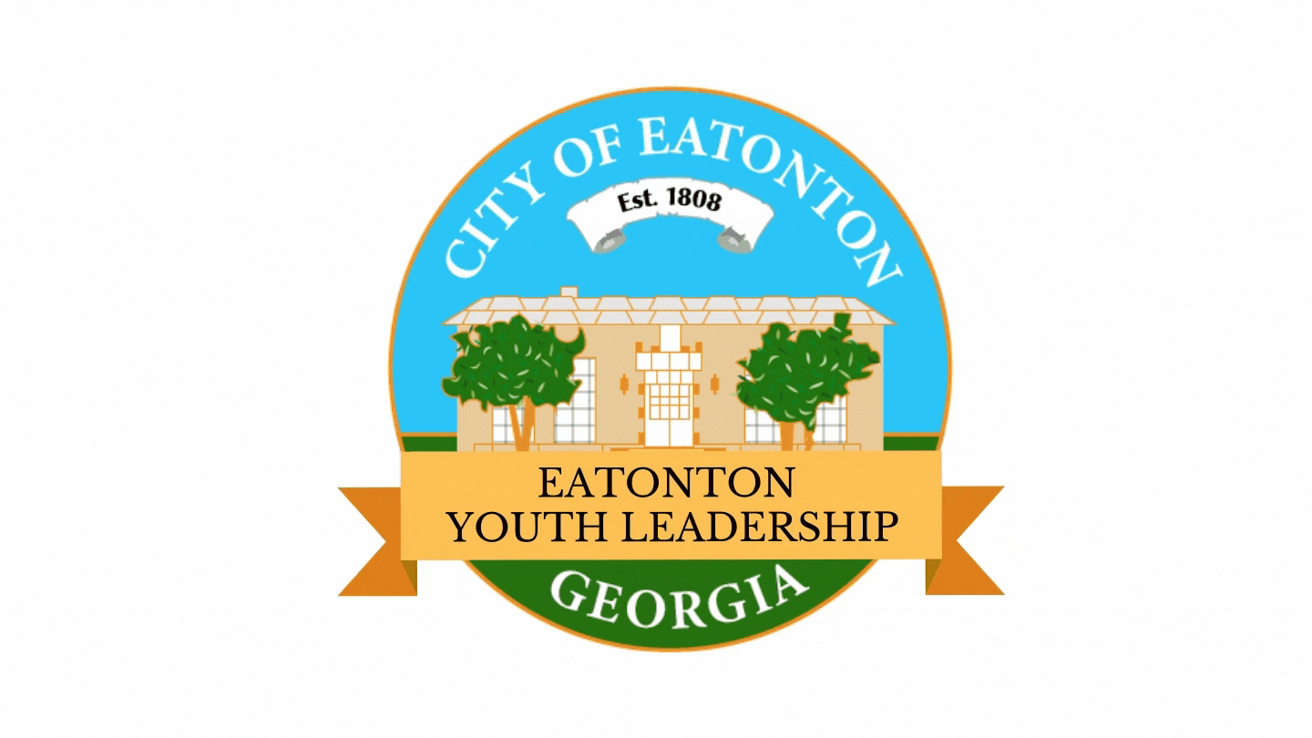

I, __________________________, do hereby promise that I desire to be a member of the City of Eatonton Youth Council; that I will honestly and faithfully perform the duties assigned to me; that I will abide by the Rules which govern Eatonton Youth Council members and that I will be a good role model for all youth in the City of Eatonton.

That I will support and defend the Constitution of the United States, the Constitution of the state of Georgia, and the charter, ordinances, and regulations of the city of Eatonton, Georgia; and I will perform the duties of this council in the best interest of the City of Eatonton to the best of my ability without fear, favor, affection, reward, or expectation thereof; so help me God.

Subscribed and sworn to before me on this 15th day of February, 2021.
___________________________
Eatonton Youth Leader

___________________________
John Reid, Mayor
City of Eatonton

