DISCLAIMER
This document is provided for general informational purposes, may not apply to your city's specific situation and should not be considered a comprehensive RFP. It should be used for comparative purposes only. The RFP should be tailored to reflect the actual context of your city. You should consult with your city attorney before taking any action based on this document.

Decatur City Hall Exterior Painting

Owner:

City of Decatur
509 North McDonough Street
P. O. Box 220
Decatur, Georgia 30031

January 8, 2018

TABLE OF CONTENTS

ITEM PAGE NUMBER

Notice to Bidders NTB-1
Instructions to Proposers IP-1 to IP-3
Non-Collusion Affidavit NC-1
Proposal P-1 to P-2
Agreement A-1 to A-2
General Conditions GC-1 to GC-8
Special General Conditions SGC-1 to SGC-2
E-Verify and SAVE Requirements E-1 to E-5
Scope of Work SCOPE-1
Attachments ATT-1 to ATT-7 NOTICE TO BIDDERS

The City of Decatur will receive sealed bids for the Decatur City Hall Exterior Painting,
Decatur, Georgia 30030, until 10:00 am, January 31, 2018 in the City Commission Room at Decatur City Hall, 509 North McDonough Street, Decatur, Georgia, 30030, at that time and place all bids will be publicly opened and read aloud. This work project includes painting the exterior of Decatur City Hall located at 509 North McDonough Street, Decatur, GA 30030.

The proposals must be delivered by the deadline to the City Manager’s Office on the 2nd Floor of Decatur City Hall, (509 North McDonough Street, Decatur, GA 30030) and shall be marked “Sealed Bid for Decatur City Hall Exterior Painting” The bidder must submit three (3) copies of their proposal with one marked original.

A pre-bid conference is scheduled for 10:30AM, January 17, 2018 at the Decatur City Hall located at the above address. A site visit will be provided as part of the meeting. Any questions regarding bids and/or misunderstandings that may arise from this proposal should be submitted, via email and should be directed to Felix Floyd, Facilities Maintenance Superintendent, at felix.floyd@decaturga.com, no later than January 24, 2018 at 3:00PM.

The bid package for the Decatur City Hall Exterior Painting is available on-line at no charge at www.decaturga.com/requestforproposals.

The Contractor must ensure that employees and applicants for employment are not discriminated against because of their gender, race, color, genetic information, religion, national origin, political affiliation, age, handicapped status, sexual orientation, sexual preference, or gender identity and expression.
Proposals will be considered only from experienced and well-equipped contractors. Prior to beginning construction, the successful bidder will provide a complete Agreement package and a certificate of insurance. The City reserves the right to reject any or all bids or to waive informalities in the bidding.

Bids may be held by the City for a period not to exceed sixty (60) days from the date of the opening of bids for the purpose of reviewing the bids and investigating the financial stability of the bidders and their demonstrated ability to perform satisfactorily, prior to awarding the contract.

NTB-1

INSTRUCTIONS TO PROPOSERS

1. EXAMINATION OF SITE AND CONTRACT DOCUMENTS

(a) Proposers shall inform themselves of all conditions under which the work is to be performed, concerning the site of the work, the structure of the ground, the obstacles which may be encountered, whether shown in the Contract Specifications or not, and all other relevant matters concerning the work to be performed.

A Contractor to whom a contract is awarded will not be allowed any extra compensation by reason of any such matters or things concerning which the Contractor did not inform themself prior to proposing. The successful Contractor must employ, as far as possible, such methods and means in the carrying out of this work as will not cause any interruption or interference with any other Contractors.

- Proposers must satisfy themselves by personal examination of the locations of the proposed work and by such other means as they may prefer locations of the proposed work and by such other means as they may prefer as to the correctness of any quantities listed in the proposal, and shall not, after submission of their proposal, dispute or complain of such estimate nor assert that there was any misunderstanding in regard to the nature or amount of work to be done.

- Before submitting a proposal, each Proposer shall examine carefully the complete Contract
Documents, including but not limited to Instructions to Proposers, Non-Collusion Affidavit,
General Conditions, Special Conditions, the Form of Agreement and Bonds (if any), Plans and Specifications and all Addenda thereto, all of which contain provisions applicable not only to the successful Proposer but also to any of your subcontractors.

- Each proposer is expected to base their proposal on materials and equipment complying fully with the Contract Specifications, and in the event you name or include in your proposal, materials or equipment which do not conform you will, if awarded a contract, be responsible for furnishing materials and equipment which fully conform at no change in his contract price.

Proposer hereby certifies that ____________________________________________, a
(Name)

duly qualified representative of ___________________________________________,
(Firm Name)

inspected all job locations on _______________________________________________.
(Fill in Dates)

IP-1

2. INTERPRETATION OF CONTRACT DOCUMENTS

If any person contemplating submitting a proposal on this project is in doubt as to the true meaning of any part of the Contract Specifications or other Sections of the Contract Documents, you may submit to the Owner a written request for an interpretation thereof. The person submitting the request will be responsible for its prompt delivery. Any interpretation of the Contract Documents including the Contract Specifications will be made only by addendum duly issued or delivered by the Owner to each person receiving a set of such documents. The Owner will not be responsible for any other explanations or interpretations of the Contract Documents including the Contract Specifications.

3. APPROXIMATE QUANTITIES

On all items on which proposals are to be received on a unit price basis the quantities stated in the Proposal will not be used in establishing final payment due the Contractor. The quantities stated on which unit prices are so invited, are approximate only, and each proposer shall make their own estimate from the Contract Specifications of the quantities required on each item and calculate your unit price proposal for each item accordingly. Proposals will be compared on the basis of number of units stated in the Proposing Schedule set forth in the Proposal. Payment on the contract on unit price items will be based on the actual number of units installed on the completed work. Lump Sum proposal items shall be supported by a Schedule of Values as established in the Contract Specifications.

4. SIGNING OF PROPOSALS

If the proposer is a corporation, the legal name of the corporation shall be set forth together with the signature of the officer or officers authorized to sign contracts on behalf of the corporation; if proposer is a co-partnership, the true name of the firm shall be set forth together with the signatures of all the partners; and if proposer is an individual, his signature shall be inscribed. If signature is by agent, other than an officer of a corporation or a member of a partnership, a power of attorney must be on file with the Owner prior to opening proposals or submitting proposals; otherwise, the proposal may be disregarded as irregular and unauthorized.

5. QUALIFICATION OF PROPOSERS

It is the intention of the Owner to award a contract only to a proposer who furnishes satisfactory evidence that they have the requisite experience and ability and that he/she has sufficient capital, facilities and plant to enable them to prosecute the work successfully and promptly, and to complete the work within the time named in the Contract Documents.

IP-2

To determine the degree of responsibility to be credited to a proposer, the Owner will weigh any evidence that the proposer or personnel guaranteed to be employed in responsible charge of the work has or has not performed satisfactorily on other contracts of like nature and magnitude or comparable difficulty at similar rates of progress.

6. DISQUALIFICATION OF PROPOSERS

More than one proposal for the work described in this Document, to be included under a Contract, from an individual, firm or partnership, a corporation or an association under the same or different names, will not be considered. Reasonable grounds for believing that any proposer is interested in more than one proposal for the work contemplated will cause the rejection of all proposals in which such proposer is interested. If there are reasonable grounds for believing that collusion exists among the proposers, the proposals of the participants in such collusion will not be considered.

7. AGREEMENT, BONDS, INSURANCE

The attention of proposers is specifically directed to the forms of agreement and bonds to be executed and types of insurance to be taken out in the event a contract award is made.

8. FAILURE TO EXECUTE AGREEMENT AND FILE REQUIRED BONDS AND INSURANCE

Failure of a successful proposer to execute the agreement and file required bonds and insurance within the required time shall be just cause for the annulment of the award. On failure of a successful proposer to execute the agreement and file the required bonds and insurance within the required time, he shall forfeit his proposal security as agreed as liquidated damages, and the proposer, by filing a proposal, agrees to this proviso. Upon annulment of an award as aforesaid, the Owner may then award a contract to the next lowest responsible proposer.

9. PROPOSALS

Proposals shall include the following forms properly executed by the Proposer:

Instructions to Proposers Form
Proposal for Construction
Non-Collusion Affidavit
Special General Conditions Form
E-Verify Forms

IP-3

NON-COLLUSION AFFIDAVIT OF PRIME BIDDER

State of ______________.
County of ______________.

______________________________________, being first duly sworn deposes and says that:

- He/She is ______________________________________________ of
(owner, partner, officer representative, or agent)

_____________________________________________, the Bidder that has submitted the attached Bid;

- He/She is fully informed respecting the preparation and contents of the attached Bid and of all pertinent circumstances respecting such Bid;

- Such Bid is genuine and is not collusive or sham bid;

- Neither the said Bidder nor any of its officers, partners, owners, agents, representatives, employees or parties in interest, including this affiant, has in any way colluded, conspired, connived or agreed, directly or indirectly, with any other Bidder, firm or person to submit a collusive or sham Bid in connection with the Contract for which the attached Bid has been submitted or to refrain from bidding in connection with such Contract, or has in any manner, directly or indirectly, sought by agreement or collusion or communication or conference with any other Bidder, firm or person to fix the price or prices in the attached Bid or of any other Bidder, or, to fix any overhead, profit or cost element of the bid price or the bid price of any other Bidder, or to secure through any collusion, conspiracy, connivance or unlawful agreement any advantage against the City of Decatur, Georgia or any person interested in the proposed Contract; and

- The price or prices quoted in the attached Bid are fair and proper and are not tainted by any collusion, conspiracy, connivance or unlawful agreement on the part of the Bidder or any of its agents, representatives, owners, employees, or parties in interest, including this affiant.

Signed: ________________________________

________________________________
(Title)
Subscribed and sworn to before me
this ________day of ______________, 20____

______________________________________
Notary Public
My commission expires _____________________ .

NC-1

PROPOSAL FOR CONSTRUCTION

STATE OF GEORGIA,
COUNTY OF DeKALB
PROPOSAL OF:
______________________________

______________________________ ______________________________

TO THE CITY MANAGER OF THE CITY OF DECATUR, GEORGIA:

The undersigned, as contractor, hereby submits this proposal for

Decatur City Hall Exterior Painting

The contractor has made a personal examination of the site of the proposed work and proposes and agrees that if this proposal is accepted to provide the necessary labor, machinery, tools, apparatus, equipment and all things necessary to complete the work in the manner and within the time stipulated in the General Conditions and proposal, all of which documents contractor declares they have carefully examined and same are annexed to and made a part of this proposal, for the Lump Sum set out below, to wit:
1. Decatur City Hall Exterior Painting

Total: $ _____________________

Total (written) __________________________________________________________

UNIT PRICES NOT IN BASE BID:

The undersigned bidder agrees to provide additional work, if added; or to delete specified work, if requested; at the unit prices listed below unless such prices have been equitably adjusted by the Owner as previously stated. The unit prices include charges for fees, layout, supervision (field and home office), general expense, taxes, insurance, labor burden, overhead and profit.

- Repair and Replace Decorative Cove
(Cove to match existing as noted on sheet ATT-1) $____________/ LF
- Repair and Replace Decorative Molding

(Mold to match existing as noted on sheet ATT-2) $____________/ LF
3. Repair and Replace 1X Fascia (To match existing as required as noted on sheet ATT-2 &3) $ ____________/LF

P-1
No contractor may withdraw his/her proposal within sixty (60) days after the actual date of the opening of thereof. Proposals may be held by the City for a period not to exceed sixty (60) days from the date of the opening of Proposals for the purpose of reviewing the Proposals and investigating the qualifications of the contractor prior to awarding the contract.

If awarded a Contract under the Proposal, the undersigned proposes to complete work within sixty (60) days of the notice to proceed.

If this proposal is accepted by the City of Decatur and the undersigned shall fail to execute a satisfactory Contract in the form of said proposed Contract and give satisfactory bonds and insurance as required by the City within ten days (Sunday excepted) from the date of notification of acceptance by the City, then the City may at its option determine that the undersigned abandoned the Contract and thereupon this proposal shall be null and void.

Contractor further declares that the full name and residence address of all persons and parties interested in the foregoing proposal as principals are as follows:

__________________________________________________________________
__________________________________________________________________ __________________________________________________________________

Signed, sealed and dated this_________ day of

_____________________, 20_______.

By __________________________

__________________________
(Title)

P-2

AGREEMENT

GEORGIA, DeKALB COUNTY

THIS AGREEMENT, made and entered into this _________ day of
_____________________, 20______, by and between the City of Decatur, Georgia, Party of the
First Part, hereinafter referred to as the City, and
________________________________________________________________________
(Corporation, Partnership or Proprietorship) of the State of Georgia, Party of the Second Part, hereinafter called the Contractor.

WITNESSETH:

That the Contractor has agreed and by these presents does agree with the City to furnish all equipment, tools, materials, skill, labor of every description, and all things necessary to carry out and complete in a good, firm, substantial and workmanlike manner the work and construction in strict conformity with the specifications for:

Decatur City Hall Exterior Painting

which together with the Proposal, Instructions to Proposers, Non-Collusion Affidavit, General Conditions, Special General Conditions, and E-Verify Forms, and Project Plans and Specifications are incorporated in and made a part of this Contract by reference.

The Contractor shall commence work under this Contract as soon as possible after the award and must complete work no later than 60 (sixty) days after the Notice to Proceed.

If said work is not completed within the time stated above, the Contractor shall be liable and hereby agrees to pay the City as liquidated damages and not as a penalty the sum of $200 dollars per calendar day for each and every day or part of a day thereafter that said work remains incomplete.

As full payment for the faithful performance of this Contract, the City shall pay said Contractor for the actual quantities of work done at the price set forth in the proposal.

Payments shall be made as follows: Upon the presentation of a Final Invoice for Payment within thirty days after the work is fully completed and accepted by the City of Decatur, the balance due hereunder shall be paid; provided, however, that final payment shall not be made until said Contractor shall submit satisfactory proof to the City that all just claims for labor, material, skill, tools, and equipment incident to said work have been

A-1

fully paid by said Contractor, and that said Contractor has settled and satisfied every lawful claim for damages against the Contractor incident to said work.

Within ten calendar days from the date of this Contract, the Contractor as principal shall provide the required Certificate of Insurance as outlined in the General Conditions for the amounts and terms as specified therein.

This Contract, executed in triplicate, constitutes the full agreement between the parties, and no part of this Contract shall be sublet by the Contractor without written approval of the City.

IN WITNESS WHEREOF, the parties hereto have set their hands and caused their seals to be affixed hereupon the day and year first above written.

 | CITY OF DECATUR, GEORGIA
 | (Party of the First Part)
 | By: ________________________
ATTEST:  __________________________  Clerk | City Manager
 | ____________________________
 | Contractor
 | (Party of the Second Part)
 | By: _______________________
 | Title: ______________________

A-2

GENERAL CONDITIONS

- HOLD HARMLESS AGREEMENT, INTERMEDIATE FORM

- CONTRACTOR'S BONDS

- CONTRACTOR’S WARRANTY

- CONTRACTOR'S INSURANCE

- NONDISCRIMINATION IN EMPLOYMENT

- DEFINITIONS

- SAFETY

- LAWS TO BE OBSERVED

- PROVISIONS OF LAW

- SUBCONTRACTORS

- LICENSES, PERMITS, AND REGULATIONS

- TAXES

- LOCATION OF EXISTING UTILITIES AND PIPING

- PROGRESS ESTIMATES AND PAYMENTS

- CHANGE IN WORK, ALTERATIONS, OMISSIONS & EXTRA WORK

- E-VERIFY AND SAVE REQUIREMENTS

GC-1

- HOLD HARMLESS AGREEMENT, INTERMEDIATE FORM

The Contractor agrees to indemnify and save harmless the Owner, the Architect, the Engineer, and all of their officers, partners, agents and employees from and against all loss or expense (including court costs and attorney's fees) by reason of liability imposed by law upon Owner, Architect or Engineer for damages because of bodily injury, including death at any time, resulting therefrom sustained by any person or persons or on account of damage to or destruction of property, real or personal, including loss of use thereof, arising out of or in consequence of performance of this work, whether such injuries to property are due or claimed to be due to the negligence of the Contractor, his Sub-Contractors, the Owner, Architect or Engineer, their officers, Partners, agents and employees except only such injury, death or damage as shall have been occasioned by the sole negligence of the Owner, Architect or Engineer.

- CONTRACTOR’S WARRANTY

Contractor warrants to the Owner that, for a period of one (1) year from the date of substantial completion, the work performed under this Contract will conform to the requirements of the Contract Drawings and Specifications and will be free from defects. If at any time prior to substantial completion or within one (1) year after substantial completion, Owner discovers that the work does not conform to the requirements of the Contract Drawings and Specifications or is not free from defects, Contractor shall promptly correct such work within a reasonable time of receiving written notice from the Owner. If the work is not corrected by Contractor within a reasonable time of receiving written notice from the Owner, Owner may undertake to correct the work. Owner’s undertaking of such corrective work shall not limit in any way Owner’s rights of recourse against Contractor or Owner’s rights of recourse against Contractor’s surety under the Faithful Performance Bond.

- CONTRACTOR'S INSURANCE

The Contractor shall, at the time of execution of this Contract, file with the Owner the certificate of insurance as contained in the Agreement, which shall cover all of the Contractor’s insurance as required herein including evidence of payment of premiums thereon, and the policy or policies of insurance covering said Owner, the Engineer and their officers, agents and employees. Each such policy and certificate shall be satisfactory to the Owner and shall bear an endorsement precluding the cancellation or reduction in coverage without giving the Owner at least fifteen (15) days prior notice thereof in writing. All policies shall be written by insurers licensed to do business in the State of Georgia and acceptable to the Owner, with a current A.M. Best rating of no less than A-:VII. All coverages indicated on the certificate of insurance shall be included in the Comprehensive General Liability and Automobile Liability insurance policies unless they are not applicable due to the nature of the work under this Contract Document. Nothing contained in these insurance requirements is to be construed as limiting the extent of the Contractor's responsibility for payment of damages resulting from its operations under this Contract.

On all required coverages, the Contractor shall secure from all subcontractors certificates of insurance as evidence that each subcontractor carries insurance to provide coverage under this Contract up to the same minimum limits required of the Contractor in this Agreement. The Contractor shall submit copies of its subcontractors’ insurance certificates to the Owner and Engineer as evidence of such insurance coverage. The Contractor acknowledges and agrees that each subcontractor performing work for this Contract will meet these minimum insurance requirements and that any costs or uninsured events arising from or involving a subcontractor working on behalf of the Contractor for this Contract is the sole responsibility of the Contractor. The Contractor agrees to indemnify said Owner for any costs, expenses or damages that may arise from any subcontractor having insufficient insurance coverage.

- Public Liability and Property Damage Insurance – The Contractor shall take out, pay for, and maintain until completion and acceptance of the work required by this Contract, public liability and property damage insurance as shall protect the Contractor and the said Owner from all claims for bodily injury and property damage which may arise because of the nature of the work or from operations under this Contract.

The Contractor is not required to have its subcontractors named as co-insureds in the Contractor’s policy of public liability and property damage; but the policy shall protect the Contractor and the Owner from contingent liability which may arise from operations of subcontractors.

Each of said policies of insurance shall provide coverage in the following minimum amounts: Commercial general liability insurance with a minimum combined bodily injury and property damage limit of One Million Dollars ($1,000,000) per occurrence, a personal and advertising injury limit of One Million Dollars ($1,000,000), a products-completed operations aggregate limit of Two Million Dollars (2,000,000) and a general aggregate limit of Two Million Dollars ($2,000,000) per location.

$1,000,000 | Each Occurrence Limit
$1,000,000 | Personal and Advertising Injury Limit
$2,000,000 | Products/Completed Operations Aggregate
$2,000,000 | General Aggregate

- Comprehensive Automobile Liability - The Contractor shall also take out, pay for, and maintain until completion and acceptance of the work required by this Contract, automobile public liability and property damage insurance as shall protect the Contractor and said Owner from claims for bodily injury or property damage which may arise from the use of motor vehicles engaged in various operations under this Contract.

The policy or policies of automobile insurance shall provide coverage in the following minimum amounts: Automobile liability insurance covering owned, hired and non-owned vehicles, with separate coverage in an amount not less than One Million Dollars ($1,000,000) combined single limit for bodily injury and property damage.

$1,000,000 |  | Bodily Injury or death to any one person
$1,000,000 |  | Bodily Injury, each occurrence
$1,000,000 |  | Property Damage, each occurrence

(c) Umbrella Policy- The Contractor shall have an umbrella policy over General Liability,
Automobile Liability, Workers’ Compensation/Employers’ Liability and any such policies that the umbrella can be placed over that involves insurance that is applicable to the work under this contract or at least applicable to the minimum required insurance under this contract. The policy shall be placed in the amount of One Million Dollars ($1,000,000) or an amount equal to that to be paid for the work being performed under this agreement, whichever is greater.

GC-3
- Workers’ Compensation Insurance - Before beginning the work, the Contractor shall furnish to the Owner satisfactory proof that it has taken out, for the period covered by the work under this Contract, Statutory Workers’ Compensation and Employers’ Liability Insurance. Such insurance shall be maintained in full force and effect during the period covered by this Contract.

- Notification of Insurance Companies - The Contractor shall advise all insurance companies to familiarize themselves with all of the conditions and provisions of this Contract, and insurance companies shall waive the right of special notification or any change or of decreased or increased work, or of cancellation of the Contract or of any other act or acts by the Owner or its authorized employees and agents, under the terms of this Contract and failure to so notify the aforesaid insurance companies of changes shall in no way relieve the insurance companies of their obligation under this Contract.

- Indemnification - The Contractor shall indemnify and save harmless the Owner, the Engineer and all of their officers, agents, and employees from all suits, actions or claims of any character brought for or on account of any injuries to or death of or damages received by any person, persons or property resulting from the operations of the Contractor or any of its subcontractors, in prosecuting the work under this Contract.

- Additional Insured-The Contractor shall name the Owner as an additional insured and shall provide Owner with proof thereof with the certificate of insurance and copy of endorsement that meets the additional insured requirement or specifically lists owner as additional insured for said contract in the policy for said work by Contractor on behalf of this Contract.

- Subrogation Waiver-The Contractor waives all rights of subrogation against the Owner. Written evidence that each respective insurer acknowledges and agrees to such waivers of subrogation rights shall be submitted to Owner prior to commencement of the project (at minimum, a certificate of insurance, followed by a copy of an endorsement or policy language evidencing the insurer’s acknowledgement of and agreement to such waiver). In the event such requirement is not met and/or any subrogation proceeding is commenced by or on behalf of the Contractor or its insurers, the Contractor shall fully indemnify and save harmless the Owner for all costs, expenses and damages resulting therefrom, and shall take action necessary to stop any subrogation proceedings by the Contractor’s insurers.

4. NONDISCRIMINATION IN EMPLOYMENT

During the performance of this Contract, the Contractor agrees as follows:
The Contractor will not discriminate against any employee or applicant for employment because of race, creed, color, religion, sex, national origin, age or disability. The Contractor will take affirmative action to ensure that applicants are employed, and that employees are treated during employment, without regard to their gender, race, color, genetic information, religion, national origin, political affiliation, age, handicapped status, sexual orientation, sexual preference, or gender identity and expression. Such action shall include, but not be limited to the following: employment, upgrading, demotion, or transfer; recruitment or recruitment advertising; layoff or termination; rates of pay or other forms of compensation; and selection for training, including apprenticeship.

GC-4

- DEFINITIONS

  - "Owner" shall mean the City of Decatur, Georgia.

  - "Engineer" shall mean the (Senior Engineer)(Assistant City Manager for Public Works) (Deputy City Manager) or his/her duly authorized representative.

  - “Substantial Completion” shall mean the stage in the progress of the work when the work or designated portion thereof is sufficiently complete in accordance with the Contract Documents so that the Owner can occupy or utilize the work for its intended use.

- SAFETY

In accordance with generally accepted construction practice, the Contractor will be solely and completely responsible for conditions of the job site, including safety of all persons and property during performance of the work. This requirement will apply continuously and not be limited to normal working hours.

The duty of the Engineer to conduct construction review of the Contractor's performance is not intended to include review of the adequacy of the Contractor's safety measures, in, on, or near the construction site.

- LAWS TO BE OBSERVED

The Contractor shall keep himself fully informed of all existing and future Federal, State, County, and municipal laws, ordinances and regulations which in any manner affect those engaged or employed in the work or the materials used in the work or the conduct of the work or the rights, duties, powers or obligations of the Owner or of the Contractor or which otherwise affect the Contract, and of all orders and decrees of bodies or tribunals having any jurisdiction or authority over the same. He shall at all times observe and comply with, and shall cause all his agents, sub-contractors and employees to observe and comply with, all such laws, ordinances, regulations, orders and decrees; and shall protect and indemnify the Owner, the Engineer and all of their officers, agents and employees, against any claim, loss or liability arising or resulting from or based upon the violation of any such laws, ordinance, regulation, order or decree, whether by himself or by his agents, sub-contractors or employees. If any discrepancy or inconsistency is discovered in the plans, Contract Drawings, Contract Specifications or other Contract Documents for the work in relation to such laws, ordinance, regulation, orders or decree, the Contractor shall forthwith report the same to the Engineer.

- PROVISIONS OF LAW

It is specifically provided that this Contract is subject to all applicable laws and that the rules of law shall prevail over any provision contained in any of the Contract Documents which may be in conflict thereto or inconsistent therewith.

- SUBCONTRACTORS

The Contractor shall notify the Owner in writing of the names of all Subcontractors he proposes to employ on the Contract and shall not employ any Subcontractors until the Owner's approval in writing covering such Subcontractors has been obtained.

GC-5
The Contractor agrees to be fully and directly responsible to the Owner for all acts and omissions of his Subcontractors and of any other person employed directly or indirectly by the Contractor or Subcontractors, and this contract obligation shall be in addition to the liability imposed by law upon the Contractor.

Nothing contained in the Contract Documents shall create any contractual relationship between any Subcontractor and the Owner. It shall be further understood that the Owner will have no direct relations with any Subcontractor. Any such necessary relations between Owner and Subcontractor shall be handled by the Contractor.

The Contractor agrees to bind every Subcontractor (and every Subcontractor of a Subcontractor, etc.) by all terms of the Contract Documents as far as applicable to the Subcontractors work unless specifically noted to the contrary in a subcontract approved in writing as adequate by the Owner.

Should any Subcontractor fail to perform in a satisfactory manner the work undertaken by him, such subcontract shall be terminated immediately by the Contractor upon notice from the Owner.

- LICENSES, PERMITS, AND REGULATIONS

The Contractor shall secure all Federal, State and Local licenses required by law. Contractor shall obtain and pay for all necessary permits. Contractor shall give all notices and comply with all laws, ordinances and regulations bearing on the conduct of the work as drawn and specified. If the Contractor observes that the drawings or Contract Specifications are at variance therewith, they shall promptly notify the Engineer in writing, and any necessary changes shall be adjusted as provided in the Contract for changes in the work.

- TAXES

Contractor shall, without additional expense to the Owner, pay all applicable Federal, State and local sales and other taxes, except taxes and assessments on the real property comprising the site of the project.

- LOCATION OF EXISTING UTILITIES AND PIPING

The location of existing and underground utilities, such as gas mains, water mains, electric lines, etc., as shown on the Contract Drawings, have been taken from the record drawings of the parent utility companies where available. However, the Owner does not assume responsibility for the possibility that during construction utilities other than those shown may be encountered or that the actual location of those shown may be different from the locations designated on the Contract Drawings. At the locations wherein detailed positions of these facilities become necessary to the new construction, the contractor shall, at his own expense, furnish all labor and tools to either verify and substantiate the record drawing location or definitely establish the position of the facilities.

Because of the nature of the work, adjustments may be required in new construction to meet existing conditions. Such adjustments shall be made by the Contractor without additional cost to the Owner.

GC-6

14. PROGRESS ESTIMATES AND PAYMENTS

No payments under this Contract will be made except upon the presentation of Periodical Estimate for Partial Payment prepared by the Contractor on forms, supplied by Owner, and approved in writing by the Engineer which shall show that the work covered by the payments has been done and the payments therefore are due in accordance with this Contract. Such Payment Forms shall be submitted to the Engineer on the 25th day of a calendar month to permit checking before the end of the calendar month.

Upon presentation of certified copies of purchase bills and freight bills the Owner will, unless specifically stated otherwise in the General Conditions of Contract, include in such monthly estimates payments for materials that will eventually be incorporated in the project, providing that such material is suitably stored on the site of the project, at the time of submission of the estimate for payment. At the time the next following monthly estimate is submitted, certified copies of receipted purchase and freight bills for the stored materials included in the previous monthly payment estimate shall be submitted. If the Contractor fails to submit proof of payment with the next monthly payment estimate, those items of stored materials for which no proof of payment has been submitted will be deleted from the current payment estimate. Such materials when so paid for by the Owner will become the property of the Owner and in case of default on the part of the Contractor the Owner may use or cause to be used by others these materials in construction of the project. However, the Contractor shall be responsible for safeguarding such materials against loss or damage of any nature whatsoever, and in case of any loss or damage the Contractor shall replace such lost or damaged materials at no cost to the Owner.

Except as otherwise provided in the immediately preceding paragraph, the first estimate shall be of the value of the work done and of materials proposed and suitable for permanent incorporation in the work, delivered and suitably and safely stored at the site of the work since the Contractor shall have begun the performance of this contract, and every subsequent estimate, except the final estimate, shall be of the value of the work done and materials delivered and suitably stored at the site of the work since the last preceding estimate was made; provided, however, that should the Contractor fail to adhere to the program of completion fixed in this Contract, the Engineer shall deduct from the next and all subsequent estimates the full calculated accruing amount of the liquidated damages (if any) to the date of said estimate, until such time as the compliance with the program has been restored; and provided, also that materials delivered to the site for which payment is included in the estimate shall not be removed from the site of the work prior to its completion without the written consent of the Engineer.

The estimates shall be signed by the Engineer and approved by the Owner, and after such approval the Owner, subject to the foregoing provisions, will pay or cause to be paid to the Contractor, in the manner provided by law, the estimated value of the work performed and of the value of the materials furnished and delivered and unused and suitably and safely stored at the site of the work, such materials to be those which are proposed and suitable for permanent incorporation in the work, less retainage of ten percent (10%).

When fifty percent (50%) of the contract value including change orders and other additions to the contract value provided for by the contract documents is due and the manner of completion of the contract work and its progress are reasonably satisfactory to the Engineer, the Owner shall withhold no more retainage. At the discretion of the Owner and with the approval of the Contractor, the retainage of each subcontractor may be released separately as the subcontractor completes his or her work.

GC-7

If, after discontinuing the retention, the Engineer determines that the work is unsatisfactory or has fallen behind schedule, retention may be resumed at the previous level. If retention is resumed by an
Owner, the contractor and subcontractors shall be entitled to resume withholding retainage accordingly.

At Substantial Completion of the work or such other standard of completion as may be provided in the contract documents and as Engineer determines the work to be reasonably satisfactory, the Owner shall, within 30 days after invoice and other appropriate documentation as may be required by the contract documents are provided, pay the retainage to the Contractor. If at that time there are any

remaining incomplete minor items, an amount equal to 200 percent of the value of each item as
determined by the Engineer shall be withheld until such item or items are completed. The reduced retainage shall be shared by the Contractor and subcontractors as their interests may appear.

- CHANGE IN WORK, ALTERATIONS, OMISSIONS & EXTRA WORK

Owner reserves the right to increase or decrease the quantity of any item or portion of the work, or to omit portions of the work, as may be deemed necessary or advisable by the Owner, and, also, to make such alternations or deviations, additions to, or omissions from the work or the Contract Drawings and Specifications, as may be determined during progress of the work to be necessary or advisable for the proper completion thereof. Upon written order of the Owner, the Contractor shall proceed with the work as increased, decreased or altered.

The Engineer is authorized to order, on behalf of the Owner, minor changes in the work which do not involve extra cost to Owner and which do not change the character of the work; they are not authorized to order any other changes, alterations, omissions, additions, or extra work, unless the same are approved in a Contract Supplement properly authorized in writing by the governing unit of the Owner. No claim of Contractor for extra compensation because of any change, alteration, omission, addition or extra work will be paid or be payable unless a written order for such charge, alteration, omission, addition or extra work, is signed by the authorized representative of the Owner.

When any changes decrease the amount of work to be done, such changes shall not constitute a basis or reason for any claim by Contractor for extra compensation or damages on account of any anticipated profits which he thereby loses on the omitted work; and Contractor shall not be entitled to any compensation or damages therefor.

- E-VERIFY REQUIREMENTS

The Contractor shall comply with O.C.G.A. sec. 13-10-19 and Georgia D.O.L. Rule 300-1.02. The Contractor and any subcontractors shall provide evidence of compliance by executing the Contractor Affidavit and Agreement included in the Request for Proposal.

GC-8

SPECIAL GENERAL CONDITIONS

- USE OF EQUIVALENT MATERIALS, PRODUCTS AND EQUIPMENT.
The materials, products and equipment described in the Plans and Specifications establish a standard of required function, dimension, appearance and quality to be met by any proposed equivalent. Proposer shall provide manufacturer's specifications and system description, product data and installation instructions, and warranty, as applicable.

- BIDDER MUST CHECK APPLICABLE BLANK BELOW:

Proposer affirms it meets exactly the project specifications:

YES__________________ NO__________________

C. DEVIATION FROM PROJECT SPECIFICATIONS MUST BE COMPLETELY
EXPLAINED BY THE PROPOSER. The Owner reserves an absolute right to approve or reject any proposed equivalent materials, products and equipment and may reject any bid which does not exactly meet the Project Specifications.

Proposer will explain exact particulars where the proposal does not meet the Project Specifications if "NO" is checked above. Use additional sheets and provide drawings, performance and test data as necessary.

__________________________________________________________________ __________________________________________________________________

- DELIVERY/COMPLETION. The work must be completed no later than sixty (60) days from the date of the notice to proceed. Proposer shall provide firm dates of work based on a notice to proceed within the stipulated City bid review period:

Start date: ________________________________
Finish date: _______________________________

- EXPERIENCE. Proposer shall submit a list of at least three (3) projects within the State of Georgia, of similar size and scope. List shall include project name, location, contact person, telephone number, contract amount and completion date.

Contractor shall use an adequate number of workers who are thoroughly trained and experienced in the necessary crafts and who are completely familiar with the specific requirements and methods need for proper performance of this work.

- WARRANTY AND/OR GUARANTY. All installation shall be under warranty, including all materials and labor, for a period of twelve (12) months against defects, defective materials and/or workmanship, such period to start upon final acceptance of work by the City of Decatur, as required by the General Conditions.

SGC-1

- SILENCE OF SPECIFICATIONS. The apparent silence of these specifications and any supplemental specifications as to any detail or omission from these specifications of a detailed description concerning any point shall be regarded as meaning only that the best commercial practices are to prevail and that only materials of first quality and correct size, type and design are to be used. All interpretations of the specifications shall be made upon the basis of this statement with the City’s interpretation to prevail.

- PRE-CONSTRUCTION MEETING. Prior to the City issuing a Notice to Proceed for the commencement of work the Contractor and any designated subcontractor(s) shall attend a preconstruction meeting with representatives of the City. The purpose of this meeting will be to establish the goals and objectives and proposed schedule for the performance of the work. The City will notify the Contractor of the date and time for this meeting once an award of contract has been made by the City Commission.

- HOURS OF OPERATION. The hours of operation available to the Contractor to perform the construction for this project are from 7:00 AM to 6:00 PM, Mondays through Fridays and from 9:00 AM to 5:00 PM on Saturdays.

- ACCESS, SECURITY AND DISPOSAL OF REFUSE.

-Contractor shall arrange access to site with Owner.
-Contractor shall maintain a clean, safe site and shall be responsible for security and protection of site during construction.
-Contractor shall remove and properly dispose of all refuse and materials generated through demolition and construction, and leave site in a clean condition at end of construction.

- ON-SITE SUPERINTENDENT. Contractor shall employ an experienced superintendent to supervise construction operations and oversee safety at the site. The superintendent shall be an employee of the Contractor and shall be present to supervise all operations by sub-contractors at the site and to receive instructions and other communications from the Owner’s representatives at the site. Contractor shall provide the name and resume of its superintendent with its bid.

SGC-2

Scope of Work City Hall Exterior Painting

- Repair or replace all deteriorated or damaged exterior wood and metal items and surfaces, as ordered by the Facility Superintendent. Building components to be repaired or replaced include, but is not limited to, rotten or damaged exterior wood items
(dimensional lumber, hardboard, millwork, trim, columns, etc.), glass & glazing, gutters, down spouts. All repairs shall be primed on all sides before painting. Repairs shall match existing wood exactly.
- Acceptable trim lumber shall be:
  - Select yellow pine, no knots.
  - Western red cedar
  - Redwood
  - Cypress • Molded PVC may be substituted if profiles match dimensional lumber exactly.

- Contractor shall prep all areas before painting.
  - Pressure wash exterior with ph neutral detergents.
  - Scrape away any loose paint.
  - Repair any surface flaws with a two part epoxy based filling system repair compound rated for exterior use. Body filler/bondo is not permitted. Apply two coats primer (oil based). Sand the surface when dry.
  - Remove old caulk. Re-caulk around door trim, windowsills and other areas that need to be sealed with a paintable exterior caulk.
  - Prime front and back of bare wood and any area where repairs have been made.
Use mold resistant primer. (Apply a minimum of two coats).
  - Use drop cloths to protect flowerbeds and lawns. Gently tie up and cover shrubs. 4. All surface repairs and prep shall be inspected by Facilities Maintenance Superintendent before priming and painting.

- The Contractor shall protect adjacent surfaces from paint smears, splatters and overspray. Cover and/or remove hardware, furniture and fixtures not being painted; uncover and/or reinstall upon completion.

- The color of trim shall be Benjamin Moore OC-17 (Off White)

- The color of the cement panels shall be Benjamin Moore HC-172 Revere Pewter (Gray)

- The color of panels for the Personnel office shall be same as above with the addition of Benjamin Moore HC-164 Puritan Gray (Darker Gray)

- Contractor shall use oil-based paint for exterior of building.

SCOPE-1

Attachments

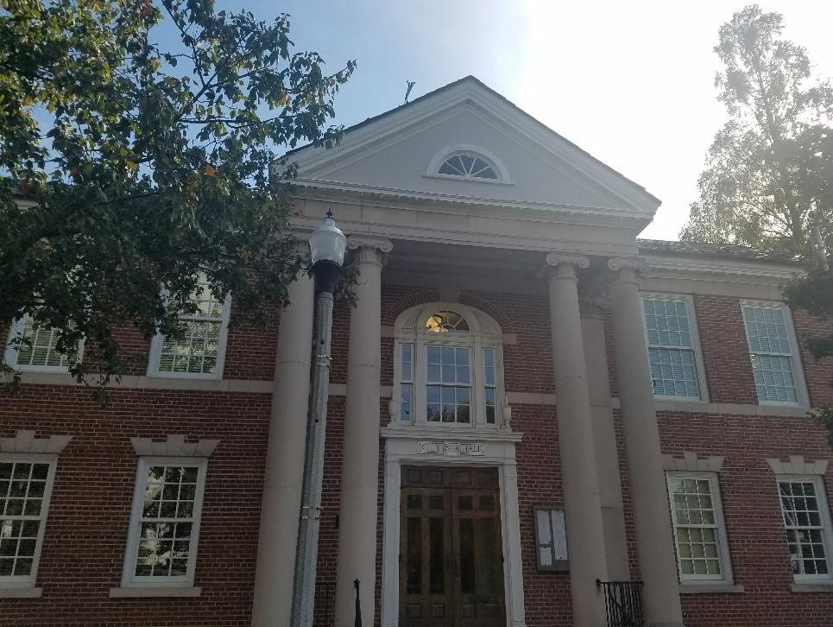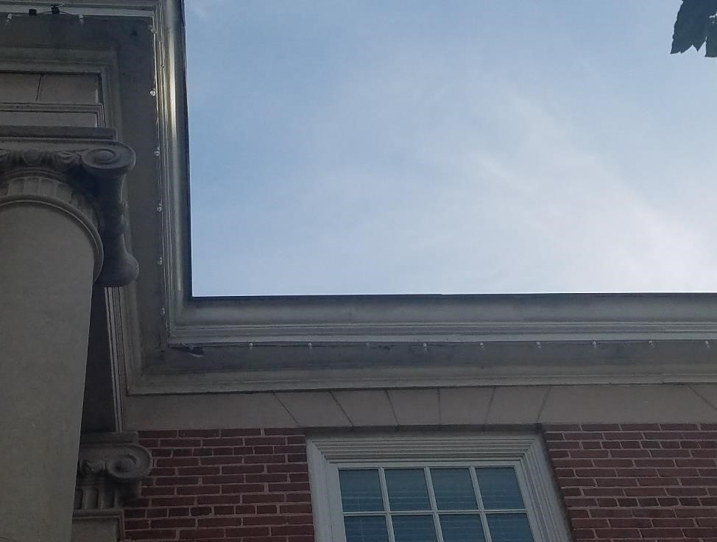
Decatur City Hall

UP1

UP1

ATT-1

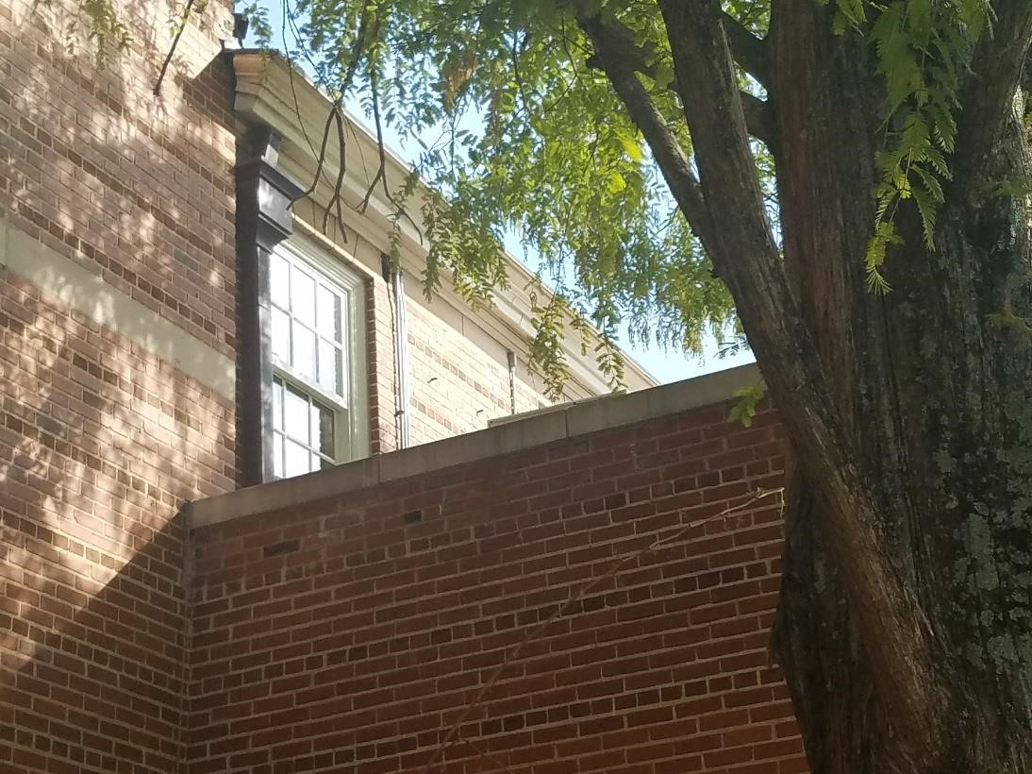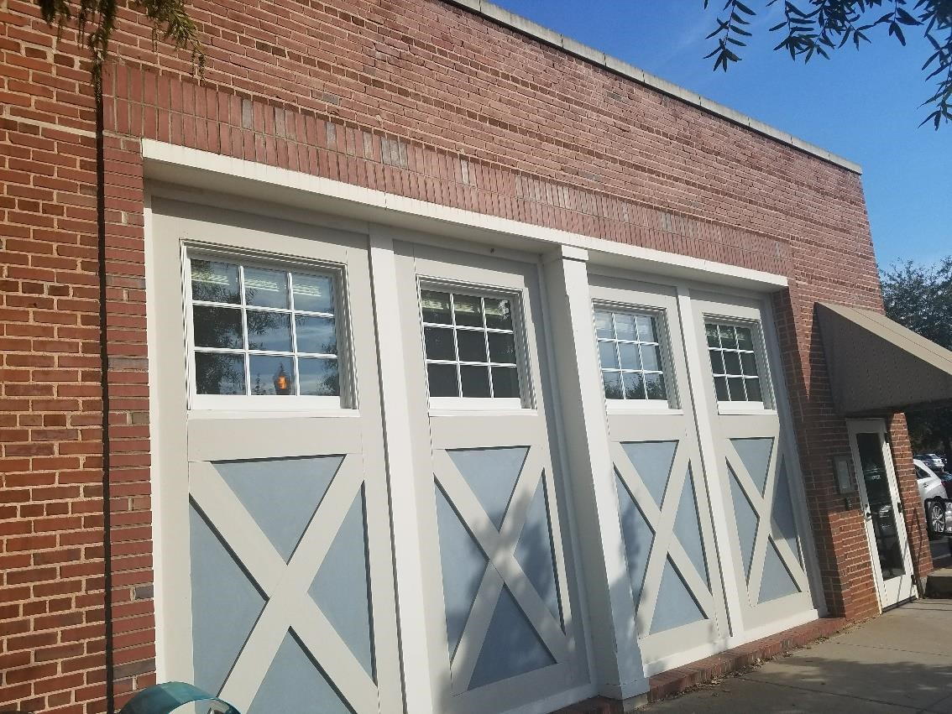

UP2

Inlay color is Benjamin Moore HC-164 Puritan Gray

ATT-2

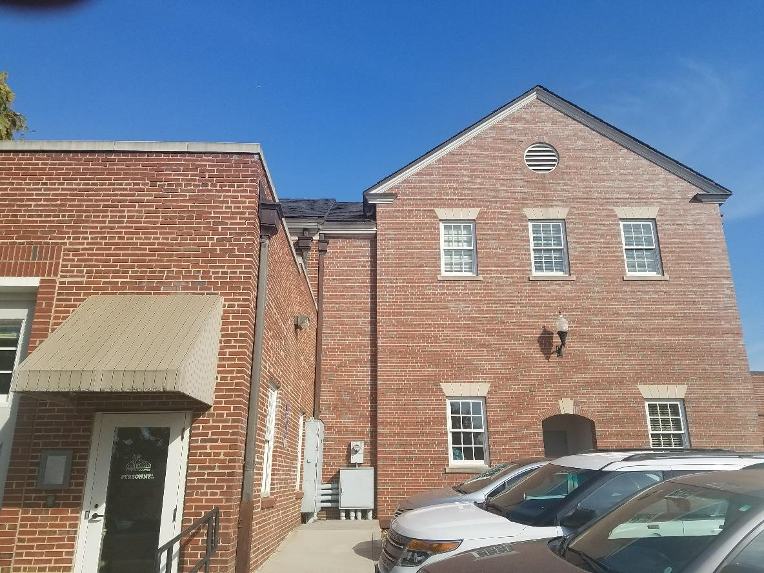

ATT-3
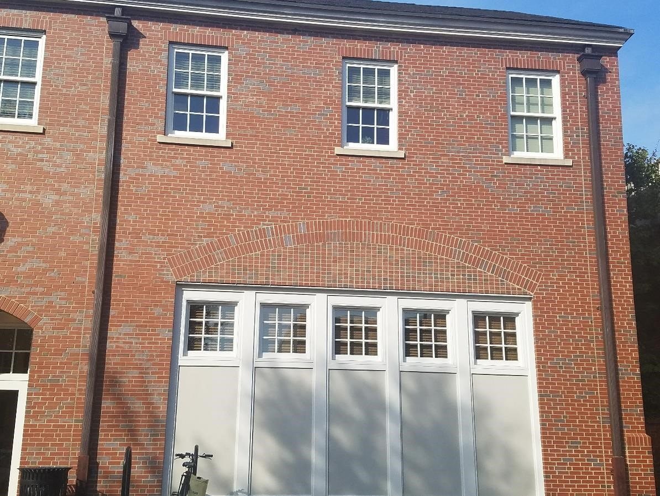

Inlay color is Benjamin Moore HC-172 Revere Pewter

ATT-4
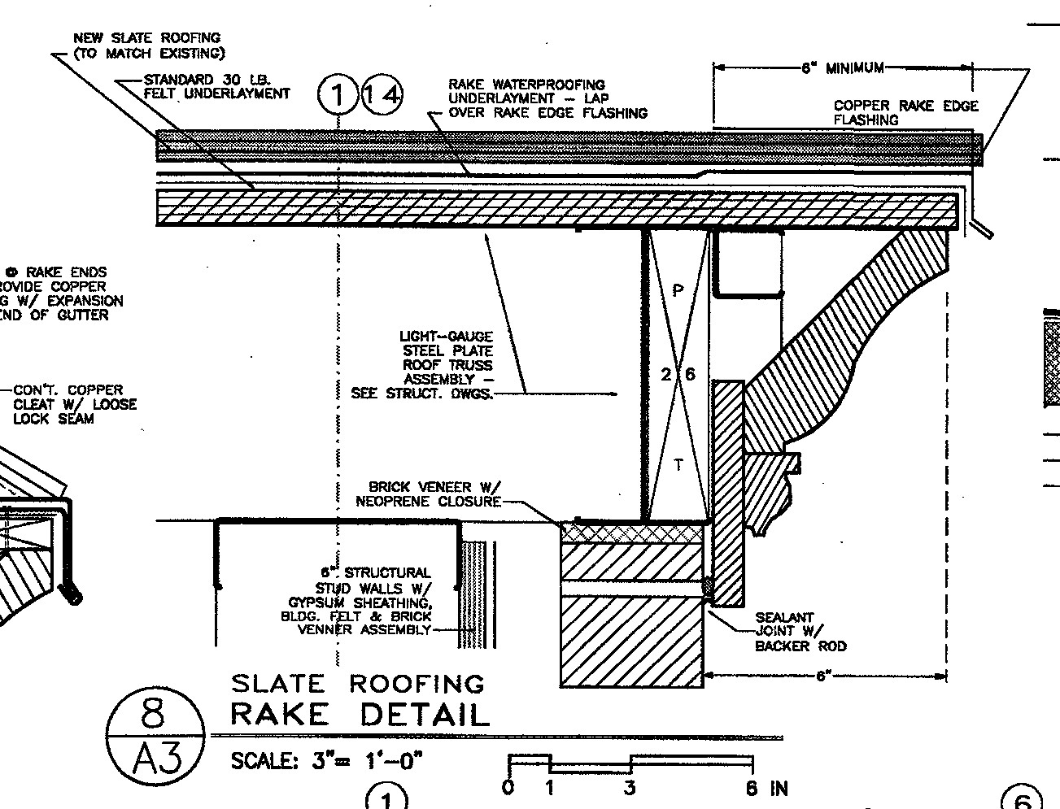

ATT-5
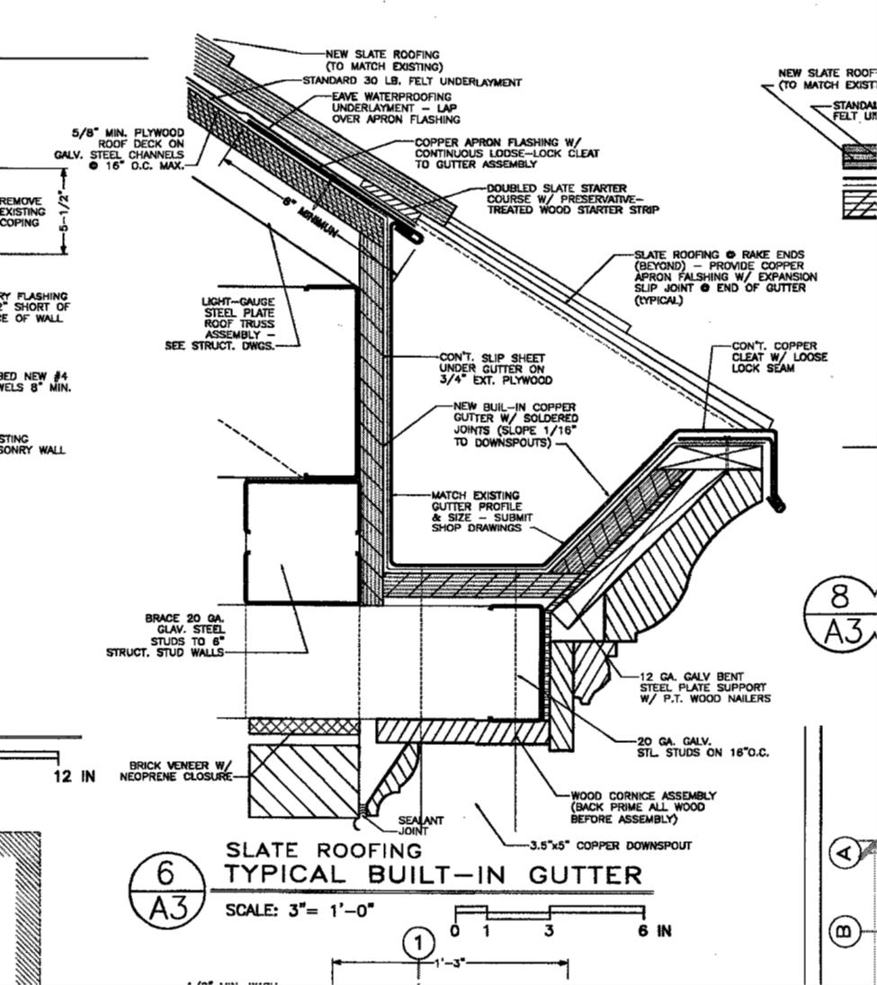

ATT-6
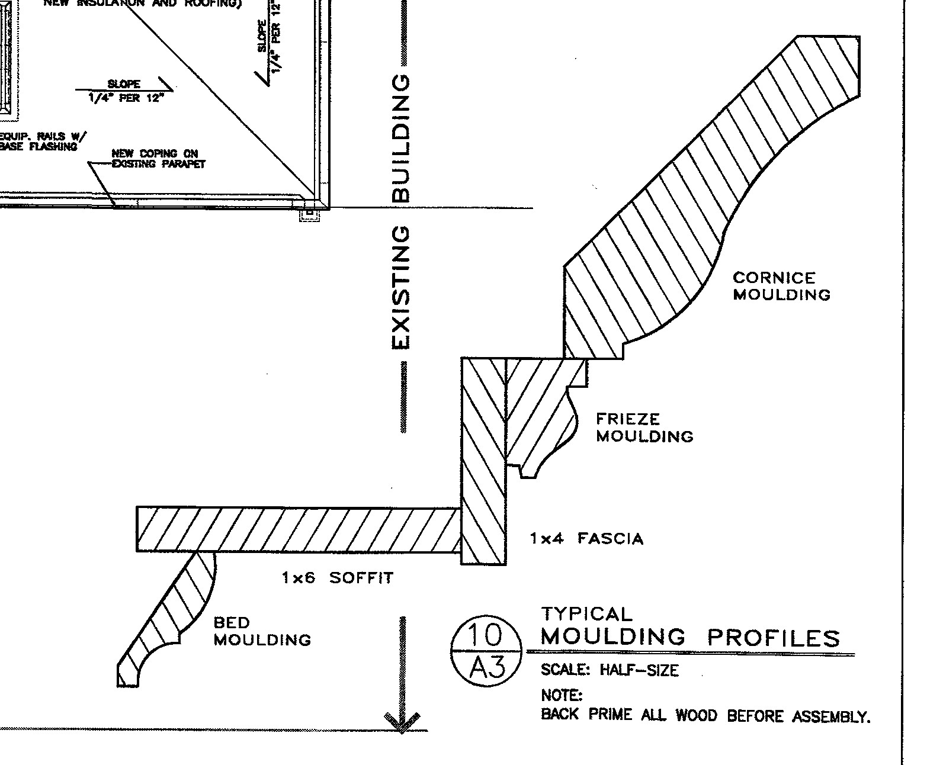

ATT-7

